- Open at least 2 of the databases from the files downloaded from Murach. (i.e. ap, ex, or om) Explore the data to get a feel for how to navigate within a database and see the data. Include two screenshots that show two different databases open and some of the data shows. Label each of the screenshots to show which database they represent.

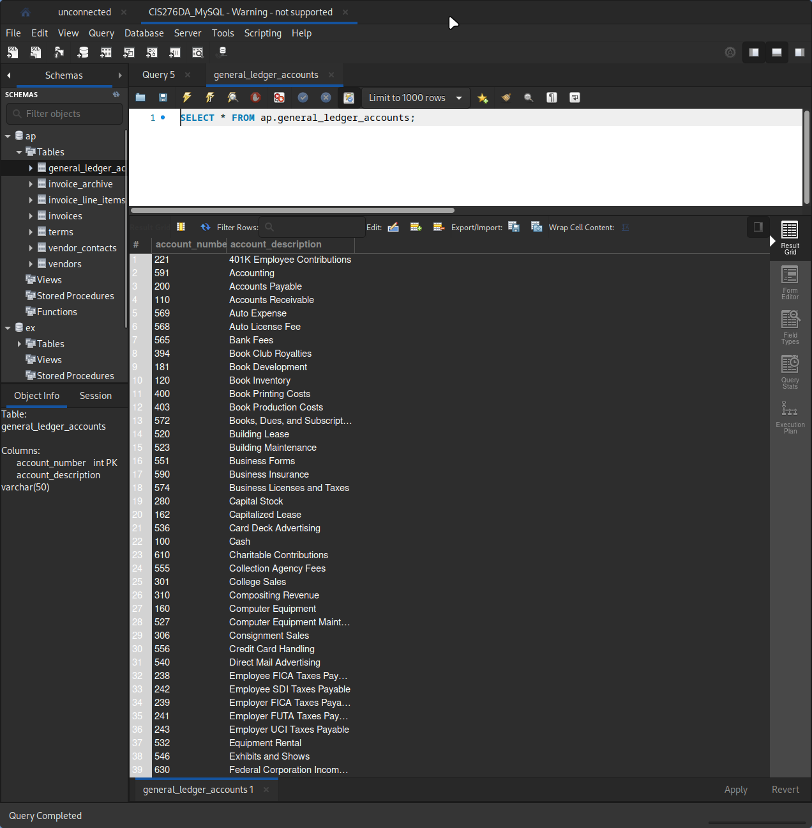
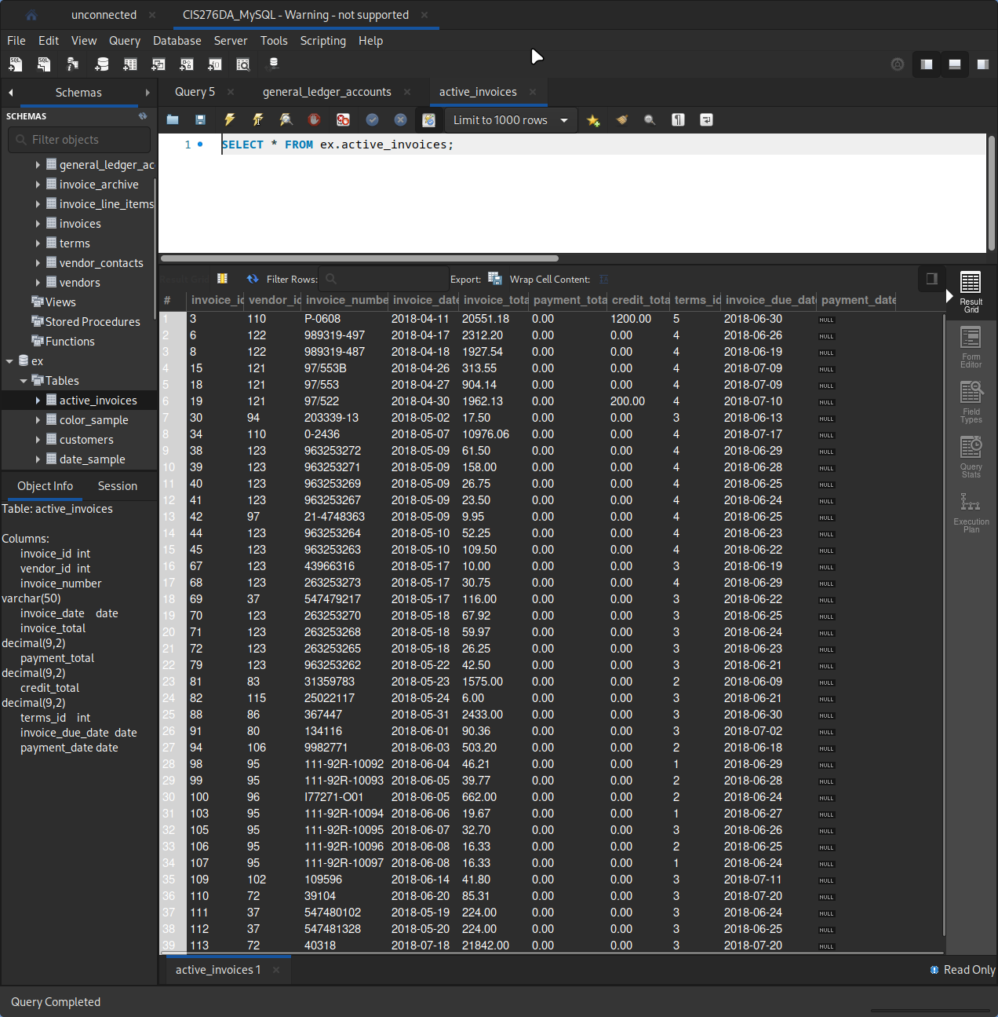

- Explore the MySQL Reference documentation. Find 5 different topics that might be useful to you as you learn about MySQL databases. For each of the 5 topics, list the topic, something you learned about that topic, and why it might be useful to you as you learn about MySQL databases.

Database Backup Methods:
I learned how to make backups of MySQL databases using the mysqldumb utility, external files, and by enabling the binary log. Backing up databases is important in case data loss occurs and allows important work to be preserved through attacks, mistakes, or disasters.

Using Encrypted Connections:
I learned how to configure a MySQL client to use an encrypted connection through TLS protocols. I learned how to create SSL and RSA certificates and keys. This is useful and interesting to me as a Cybersecurity major, as keeping connections secure in future MySQL applications will be important for maintaining access control and data integrity in future jobs.

Optimizing the MySQL Server:
I learned how to optimize a MySQL server by optimizing disk I/O, using symbolic links, and optimizing memory use. All of these concepts will be useful for the remainder of this class, as databased become larger and queries become more complex. It will also be useful for future jobs where I may be managing enterprice scale MySQL databases.

Language Structure:
I learned how MySQL syntax is formatted and what some common keywords, reserved words, variable types, and object properties are used in MySQL database management. This will be useful to learning about MySQL databases, as an understanding of these human-readable terms and what they do is the basis of MySQL database management.

Data Types:
I learned the different types of data that a MySQL database commonly stores. Knowing what types of data a database stores is useful to know how columns in future custom databases should be formatted, and to inform creative problem solving while creating data storage strategies.

